SELECT from Nobel Tutorial

1. SELECT yr, subject, winner

FROM nobel

WHERE yr = 1950  
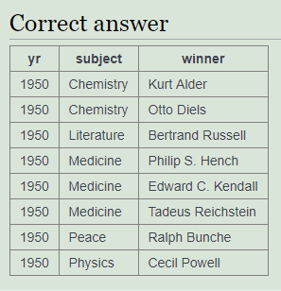

1. SELECT winner FROM nobel WHERE yr = 1962 AND subject = 'Literature'

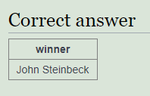

1. select yr, subject from nobel where winner = 'Albert Einstein'

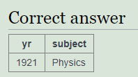

1. select winner from nobel where subject = 'Peace' and yr >= 2000

|  |
| --- |
| **winner** |
| Tunisian National Dialogue Quartet |
| Kailash Satyarthi |
| Malala Yousafzai |
| European Union |
| Ellen Johnson Sirleaf |
| Leymah Gbowee |
| Tawakel Karman |
| Liu Xiaobo |
| Barack Obama |
| Martti Ahtisaari |
| Intergovernmental Panel on Climate Change |
| Al Gore |
| Grameen Bank |
| Muhammad Yunus |
| International Atomic Energy Agency |
| Mohamed ElBaradei |
| Wangari Maathai |
| Shirin Ebadi |
| Jimmy Carter |
| United Nations |
| Kofi Annan |
| Kim Dae-jung |

1. select yr, subject, winner from nobel where subject = 'Literature' and yr between 1980 and 1989

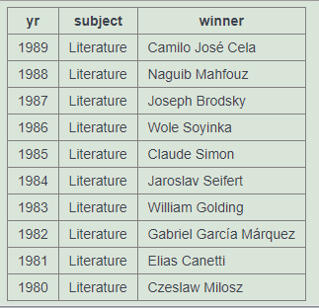

1. select * from nobel where winner in ('Theodore Roosevelt','Woodrow Wilson','Jimmy Carter','Barack Obama')

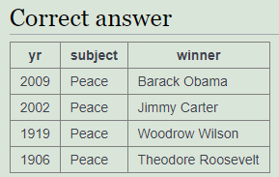

1. select winner from nobel where winner like 'John %'

|  |
| --- |
| **winner** |
| John O'Keefe |
| John B. Gurdon |
| John C. Mather |
| John L. Hall |
| John B. Fenn |
| John E. Sulston |
| John Pople |
| John Hume |
| John E. Walker |
| John C. Harsanyi |
| John F. Nash Jr. |
| John C. Polanyi |
| John R. Vane |
| John H. van Vleck |
| John Cornforth |
| John R. Hicks |
| John Bardeen |
| John C. Kendrew |
| John Steinbeck |
| John Bardeen |
| John F. Enders |
| John Cockcroft |
| John H. Northrop |
| John R. Mott |
| John Galsworthy |
| John Macleod |

1. select yr, subject, winner from nobel where subject = 'Physics' and yr = 1980 or subject = 'Chemistry' and yr = 1984

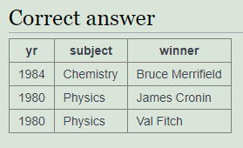

1. select yr, subject, winner from nobel where yr = 1980 and subject not in ('Chemistry','Medicine')

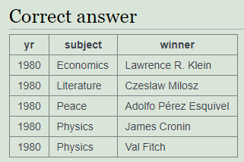

1. select yr, subject, winner from nobel where subject = 'Medicine' and yr > 1910 or subject = 'Literature' and yr >= 2004

|  |  |  |
| --- | --- | --- |
| **yr** | **subject** | **winner** |
| 2015 | Literature | Svetlana Alexievich |
| 2015 | Medicine | Tu Youyou |
| 2015 | Medicine | William C. Campbell |
| 2014 | Literature | Patrick Modiano |
| 2014 | Medicine | Edvard Moser |
| 2014 | Medicine | John O'Keefe |
| 2014 | Medicine | May-Britt Moser |
| 2013 | Literature | Alice Munro |
| 2013 | Medicine | James E. Rothman |
| 2013 | Medicine | Randy W. Schekman |
| 2013 | Medicine | Thomas C. Südhof |
| 2012 | Literature | Mo Yan |
| 2012 | Medicine | John B. Gurdon |
| 2012 | Medicine | Shinya Yamanaka |
| 2011 | Literature | Tomas Tranströmer |
| 2011 | Medicine | Bruce Beutler |
| 2011 | Medicine | Jules A. Hoffmann |
| 2011 | Medicine | Ralph M. Steinman |
| 2010 | Literature | Mario Vargas Llosa |
| 2010 | Medicine | Robert G. Edwards |
| 2009 | Literature | Herta Müller |
| 2009 | Medicine | Carol W. Greider |
| 2009 | Medicine | Elizabeth Blackburn |
| 2009 | Medicine | Jack W. Szostak |
| 2008 | Literature | Jean-Marie Gustave Le Clézio |
| 2008 | Medicine | Françoise Barré-Sinoussi |
| 2008 | Medicine | Luc Montagnier |
| 2008 | Medicine | Harald zur Hausen |
| 2007 | Literature | Doris Lessing |
| 2007 | Medicine | Mario R. Capecchi |
| 2007 | Medicine | Sir Martin J. Evans |
| 2007 | Medicine | Oliver Smithies |
| 2006 | Literature | Orhan Pamuk |
| 2006 | Medicine | Andrew Z. Fire |
| 2006 | Medicine | Craig C. Mello |
| 2005 | Literature | Harold Pinter |
| 2005 | Medicine | Barry J. Marshall |
| 2005 | Medicine | J. Robin Warren |
| 2004 | Literature | Elfriede Jelinek |
| 2004 | Medicine | Richard Axel |
| 2004 | Medicine | Linda B. Buck |
| 2003 | Medicine | Paul C. Lauterbur |
| 2003 | Medicine | Sir Peter Mansfield |
| 2002 | Medicine | Sydney Brenner |
| 2002 | Medicine | H. Robert Horvitz |
| 2002 | Medicine | John E. Sulston |
| 2001 | Medicine | Leland H. Hartwell |
| 2001 | Medicine | Tim Hunt |
| 2001 | Medicine | Sir Paul Nurse |
| 2000 | Medicine | Arvid Carlsson |
| Results truncated. Only the first 50 rows have been shown. | | |

1. select * from nobel where winner = 'PETER GRÜNBERG'

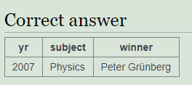

1. select * from nobel where winner = 'EUGENE O''NEILL'

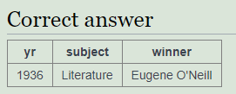

1. select winner, yr, subject from nobel where winner like 'Sir%' order by yr desc, winner

|  |  |  |
| --- | --- | --- |
| **winner** | **yr** | **subject** |
| Sir Martin J. Evans | 2007 | Medicine |
| Sir Peter Mansfield | 2003 | Medicine |
| Sir Paul Nurse | 2001 | Medicine |
| Sir Harold Kroto | 1996 | Chemistry |
| Sir James W. Black | 1988 | Medicine |
| Sir Arthur Lewis | 1979 | Economics |
| Sir Nevill F. Mott | 1977 | Physics |
| Sir Bernard Katz | 1970 | Medicine |
| Sir John Eccles | 1963 | Medicine |
| Sir Frank Macfarlane Burnet | 1960 | Medicine |
| Sir Cyril Hinshelwood | 1956 | Chemistry |
| Sir Robert Robinson | 1947 | Chemistry |
| Sir Alexander Fleming | 1945 | Medicine |
| Sir Howard Florey | 1945 | Medicine |
| Sir Henry Dale | 1936 | Medicine |
| Sir Norman Angell | 1933 | Peace |
| Sir Charles Sherrington | 1932 | Medicine |
| Sir Venkata Raman | 1930 | Physics |
| Sir Frederick Hopkins | 1929 | Medicine |
| Sir Austen Chamberlain | 1925 | Peace |
| Sir William Ramsay | 1904 | Chemistry |

1. SELECT winner, subject FROM nobel WHERE yr=1984 ORDER BY subject IN ('Physics','Chemistry'),subject,winner

